**Under the sub heading make a drop down like this**

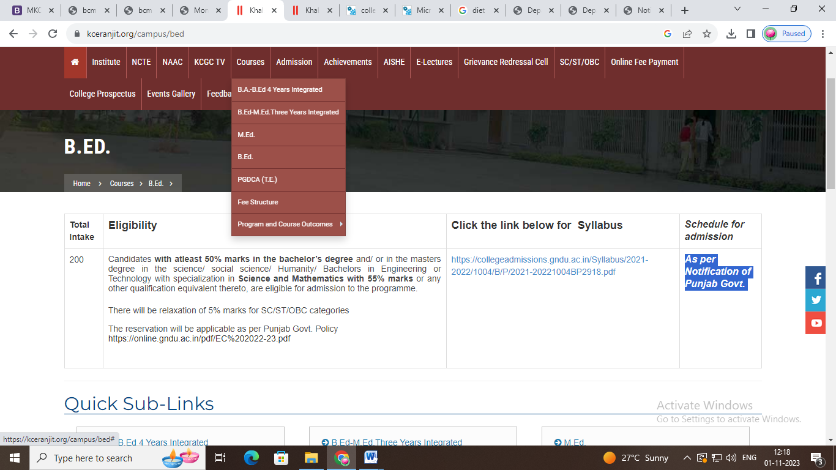

**Only Add B.Ed. and D.El.Ed Only**

**B.Ed.**

|  |  |  |
| --- | --- | --- |
| **Total Intake** | **Eligibility** | **Schedule for admission** |
| 100 | Candidates with at least 50% marks in the bachelor’s degree and/ or in the Master’s degree in the science/ social science/ Humanity/ Bachelors in Engineering or Technology with specialization in Science and Mathematics with 55% marks or any other qualification equivalent thereto, are eligible for admission to the programme.  There will be relaxation of 5% marks for SC/ST/OBC categories  The reservation will be applicable as per Punjab Govt. Policy  https://online.gndu.ac.in/pdf/EC%202022-23.pdf | As per Notification of Punjab Govt. |

**D.El.Ed.**

|  |  |  |
| --- | --- | --- |
| **Total Intake** | **Eligibility** | **Schedule for admission** |
| 50 | * Candidates should have passed Graduation with minimum 50% marks in case of general category and 45 % in case of SC, ST and other Backward Classes/ BC and physically handicapped candidates from recognized institution. No candidate with re-appear/compartment/ result later etc. in qualifying examination shall be eligibile for admission. * Candidates must have passed punjabi upto Metric level/Standard. * To ensure high quality standards, any candidate who has not passed in the subjects –English, Hindi, Punjabi, Science, Social Studies and Mathematics in Class X examination shall not be eligible for admission to D.El.Ed. course. | As per Notification of SCERT. |